1. 
2. 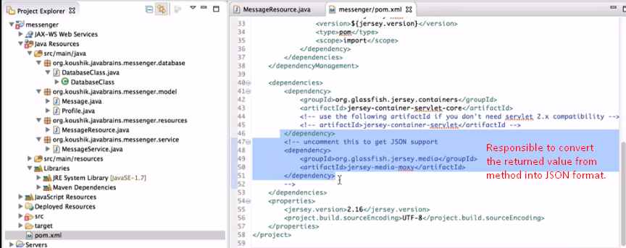
3. 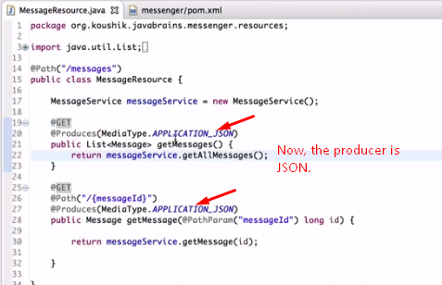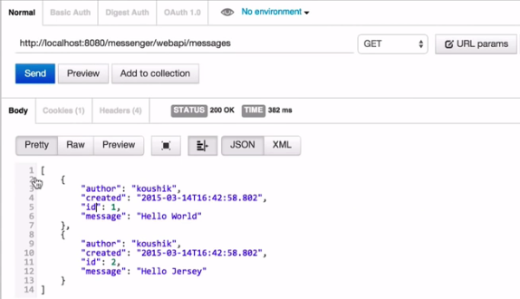  
   Later, we will look at this in detail how this all is happening.  
   There is **MessageBodyReader** and **MessageBodyWriter** which are the main actor doing all this.